1. check that you have all parts (refer to BOM – bill of materials)

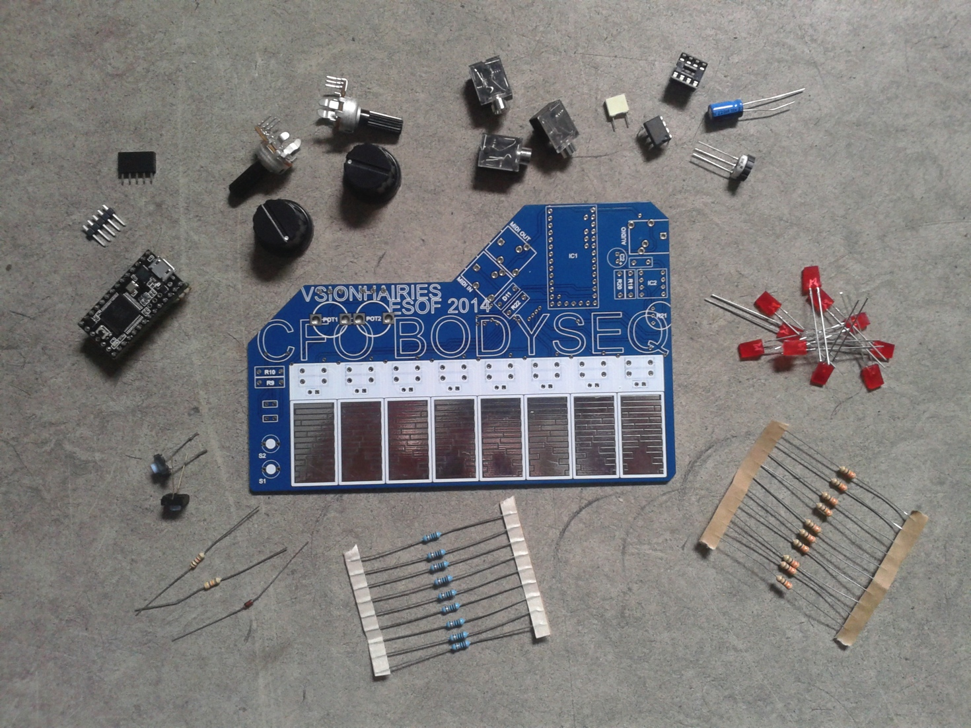

1. solder R1 - R10 (330 ohm resistors)

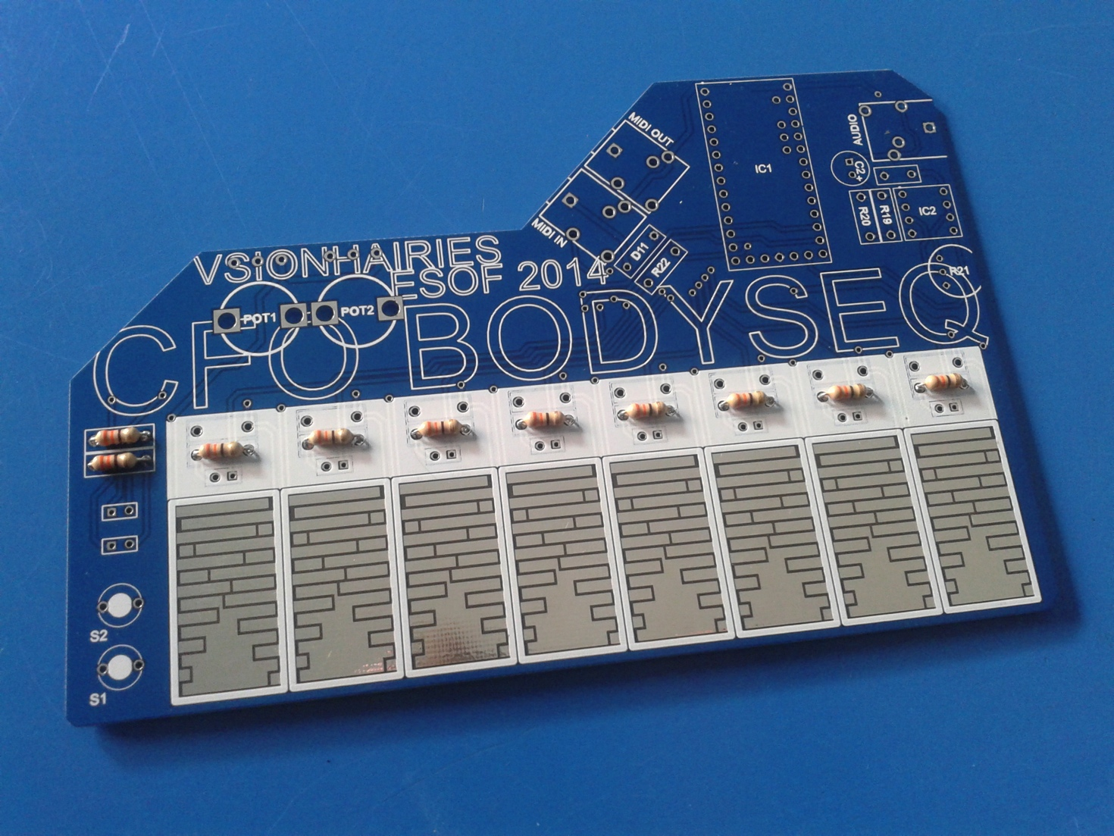

1. solder R11-R18 and R20 (10k resistors)

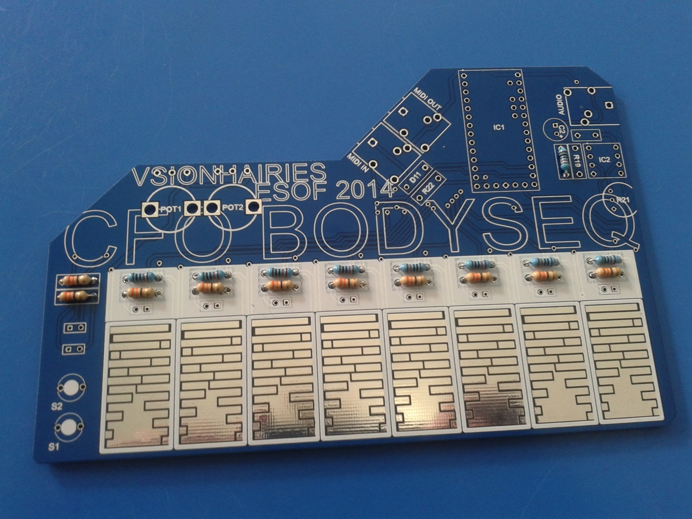

1. solder R19 (47k resistor) + R22 (1k resistor)

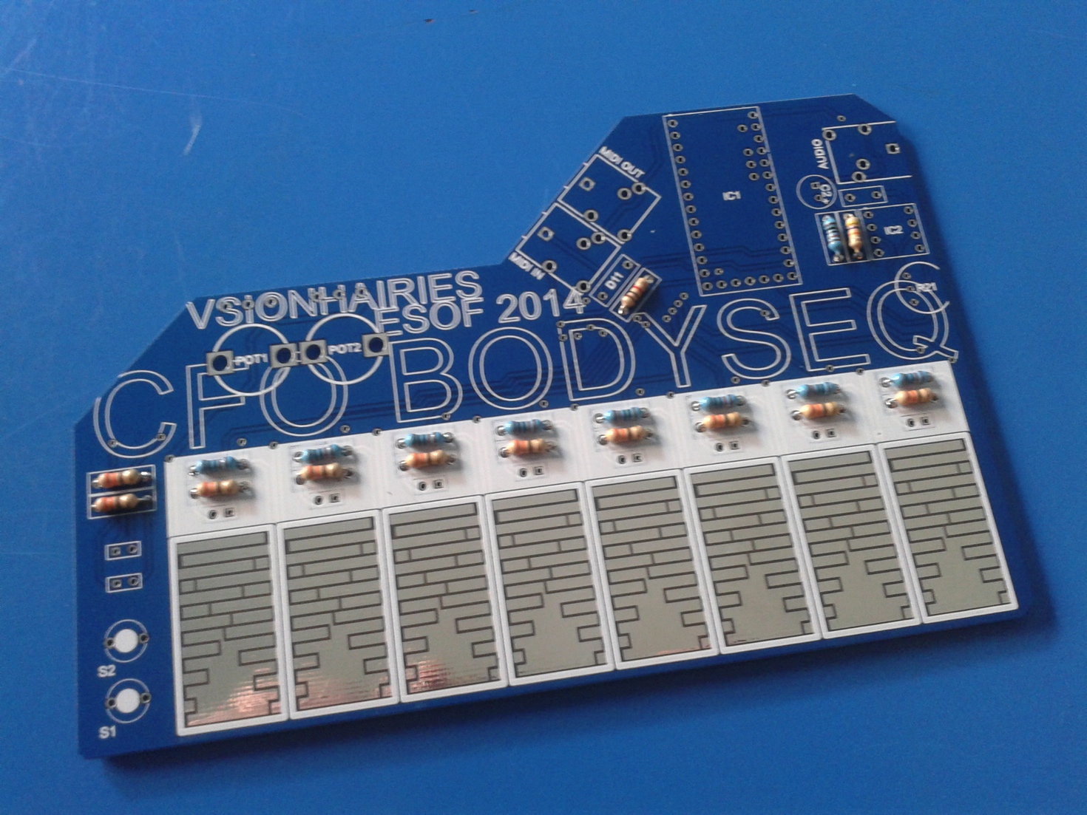

1. solder diode D11 (NB: make sure you have the polarity right / turn it the right way)

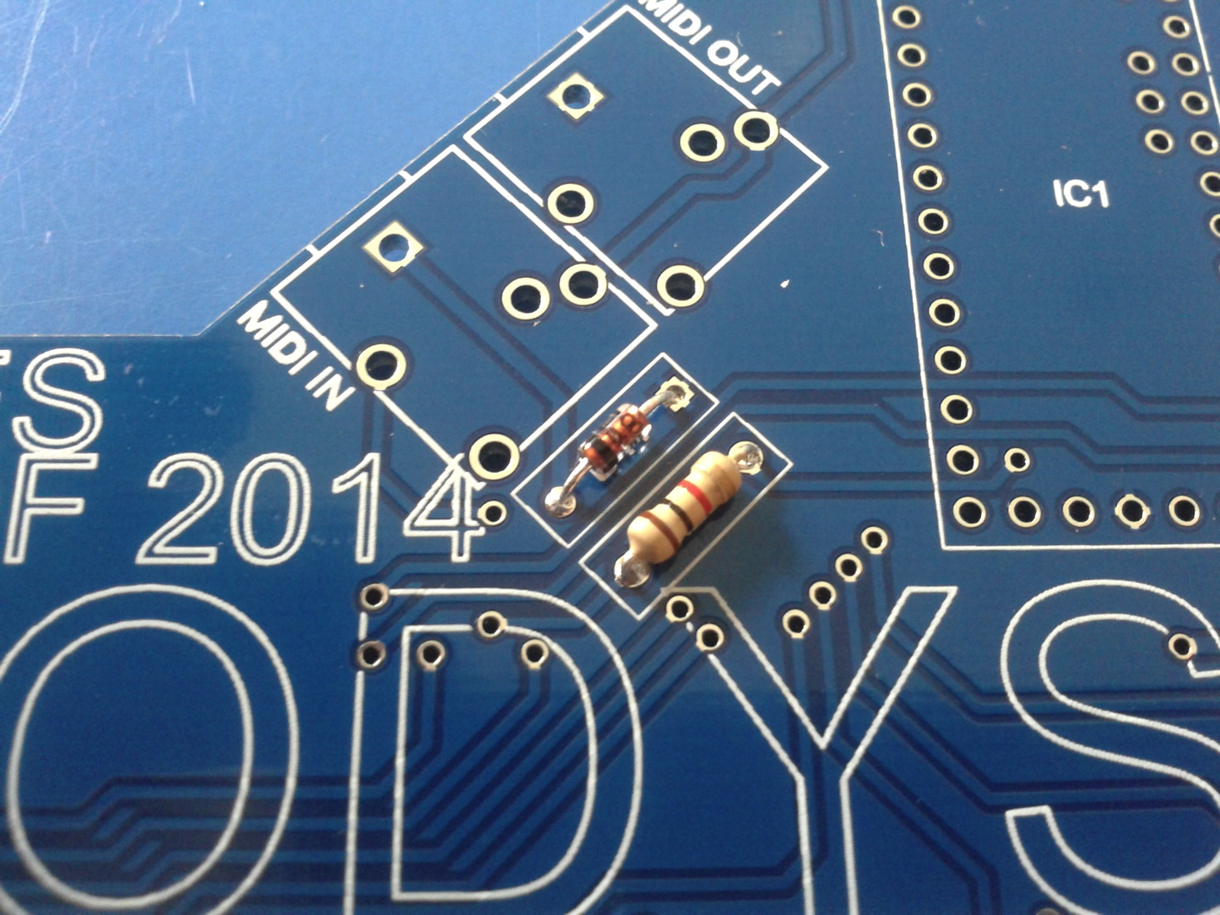

1. solder tactile switches S1+S2

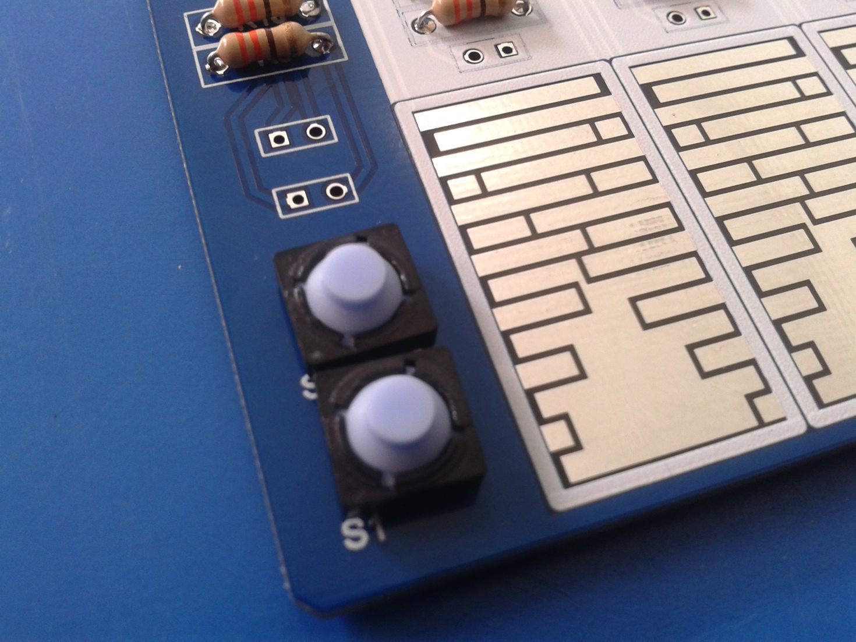

1. solder C1 (100 nF capacitor)

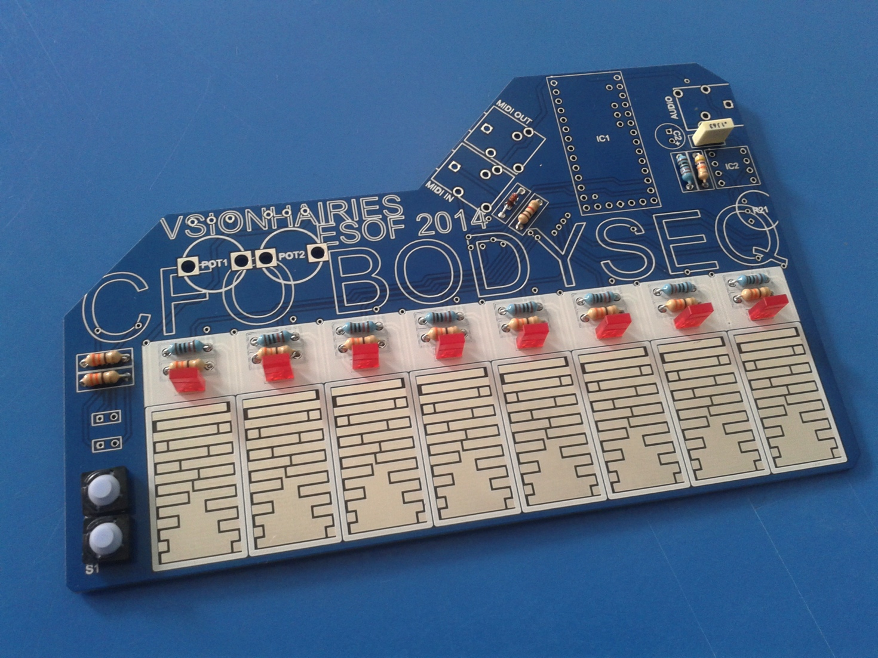

1. solder step sequencer LEDs D1-D8 (NB: polarity: plus is RIGHT leg)



1. solder LEDs D9-10 (NB: polarity: plus is LEFT leg)

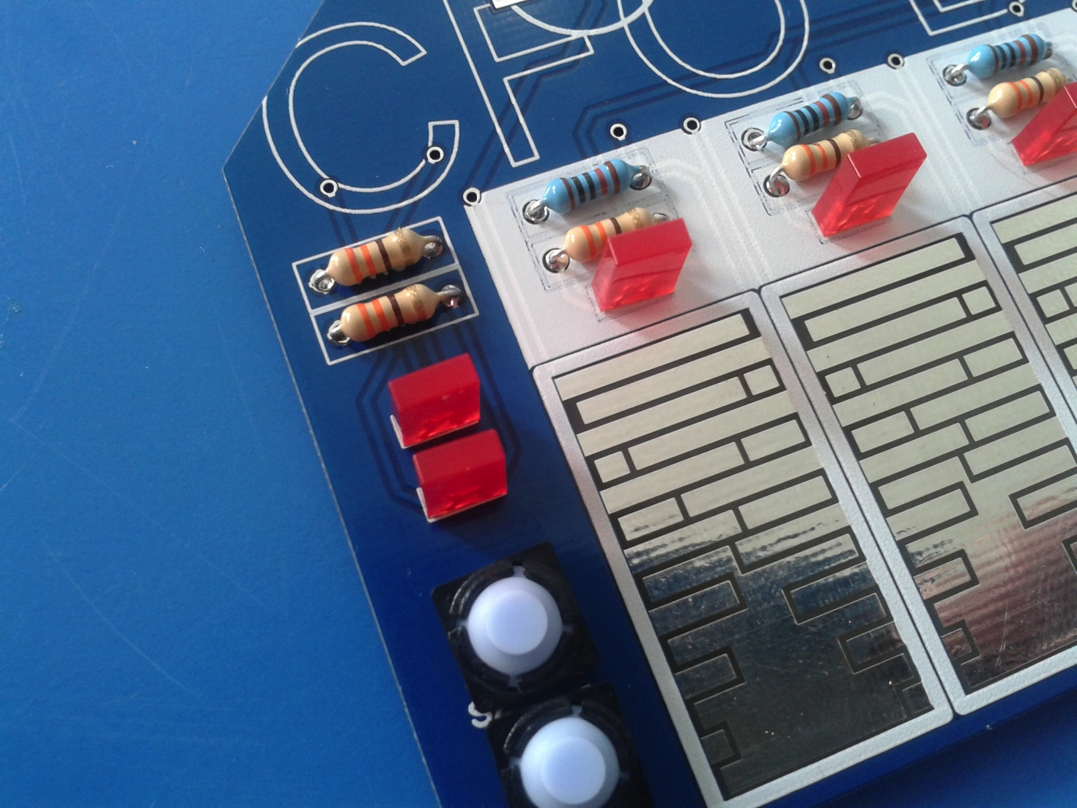

1. solder thumbwheel potentiometer R21 + IC socket IC2 (NB: make sure the IC socket is oriented upwards: the marker/indent should be on top)

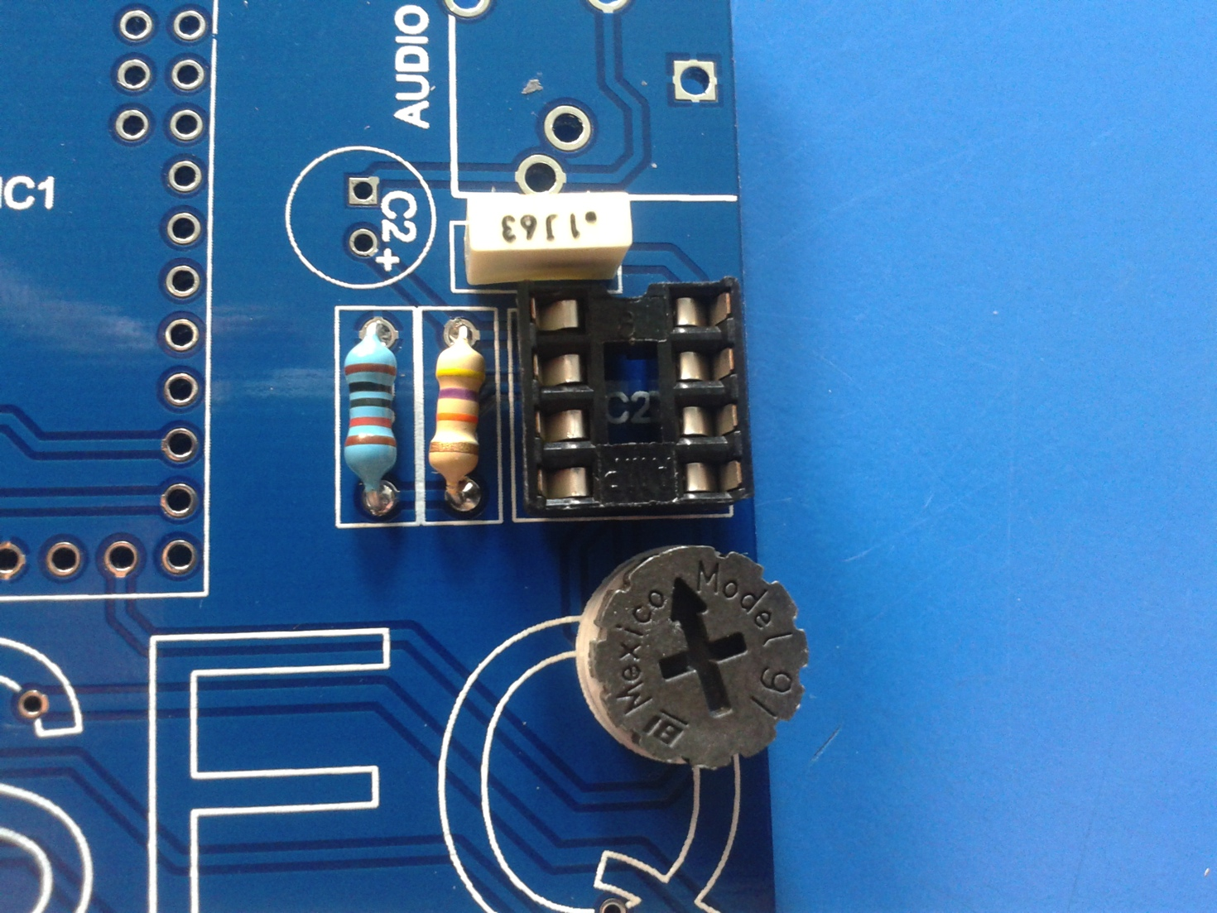

1. solder mini jacks AUDIO, MIDI IN, MIDI OUT

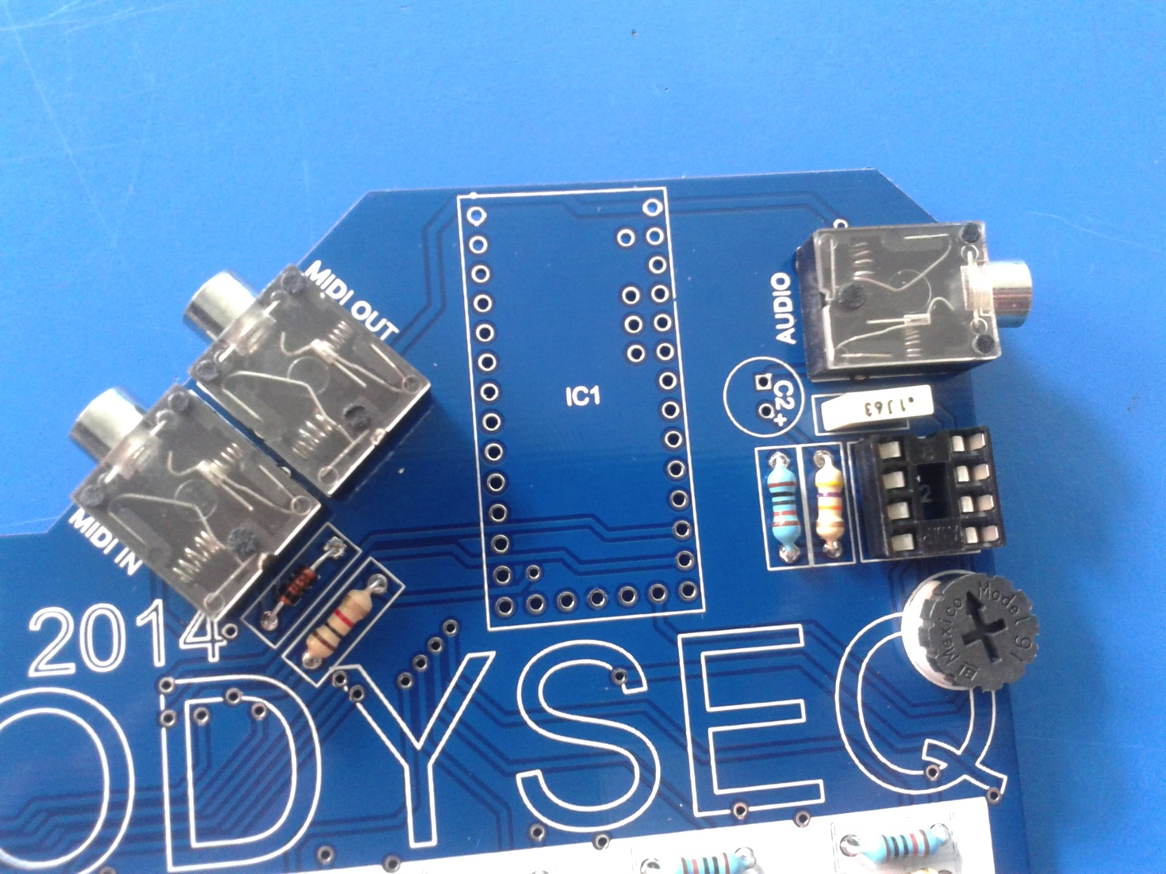

1. solder C2 (XX radial capacitor, NB: make sure you have the polarity right / turn it the right way)

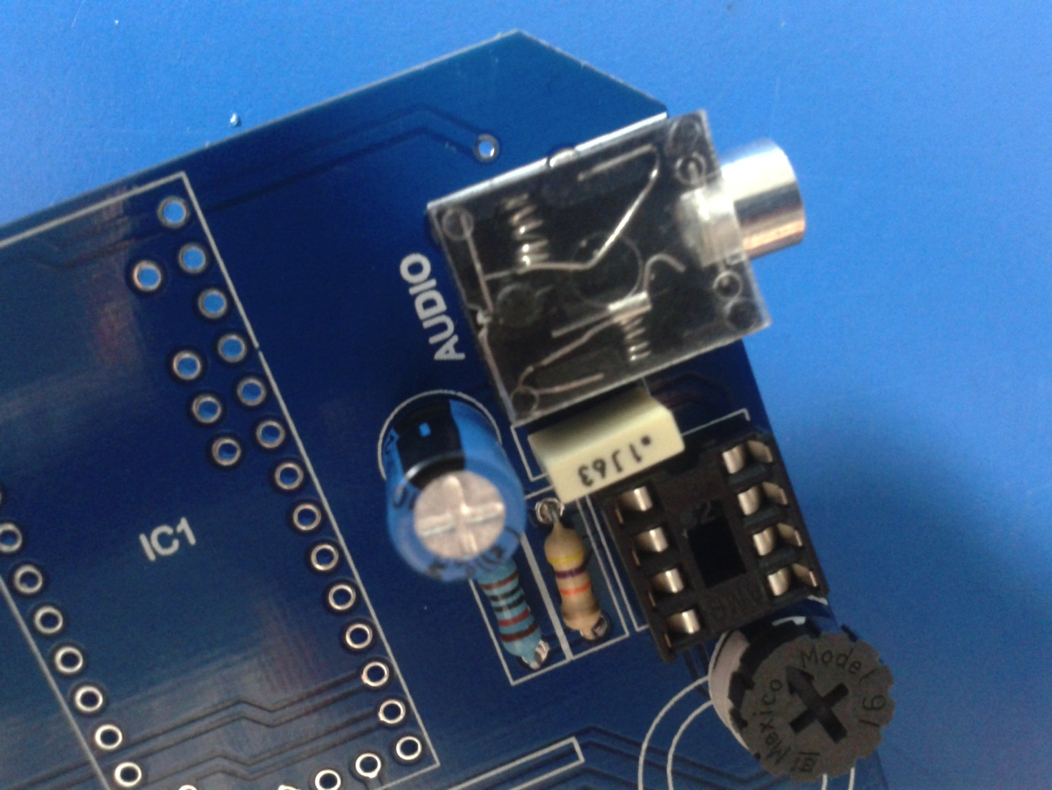

1. solder male pin headers to teensy 3.1 microcontroller

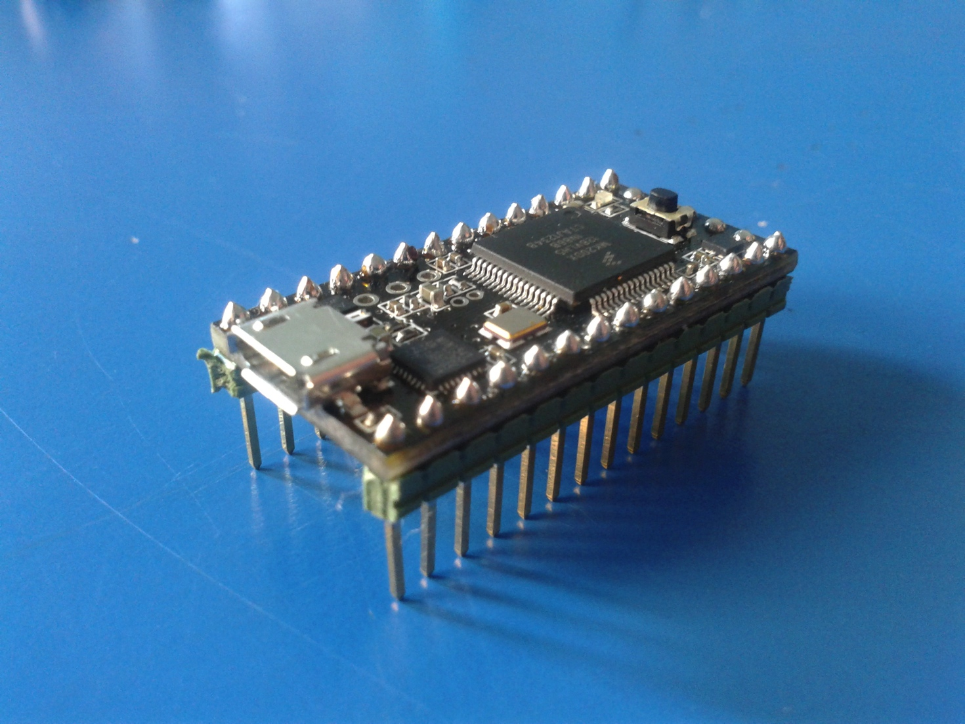

1. solder female pin headers to CFO BODYSEQ

***PIC PENDING***

1. attach teensy 3.1 and IC (both facing upwards)

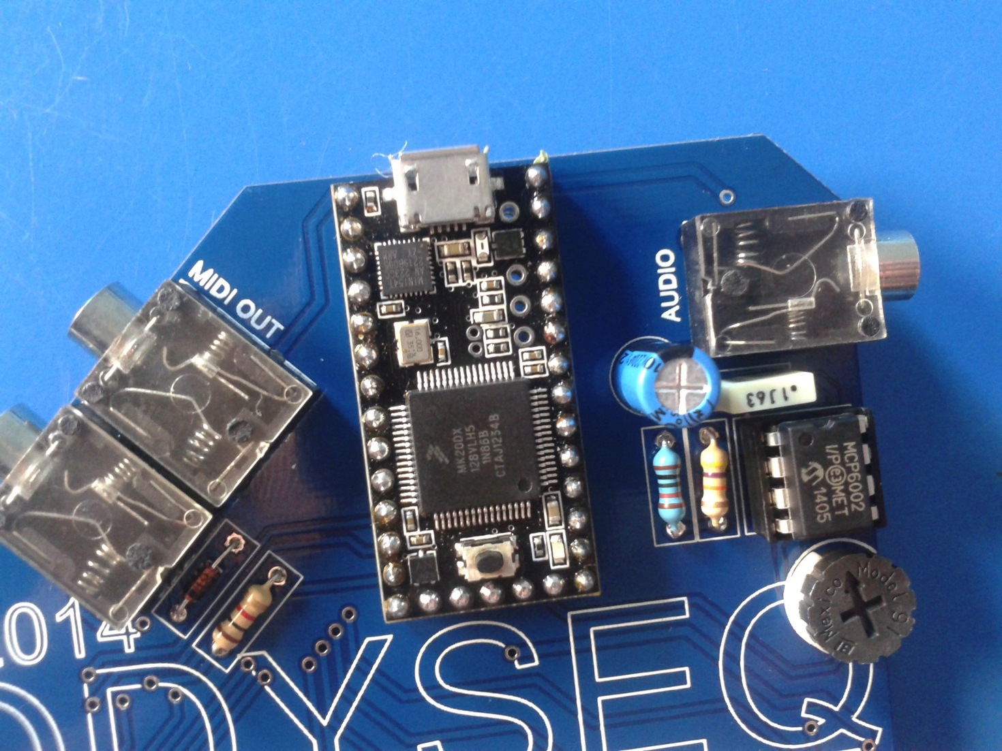

1. solder POT1 + POT2

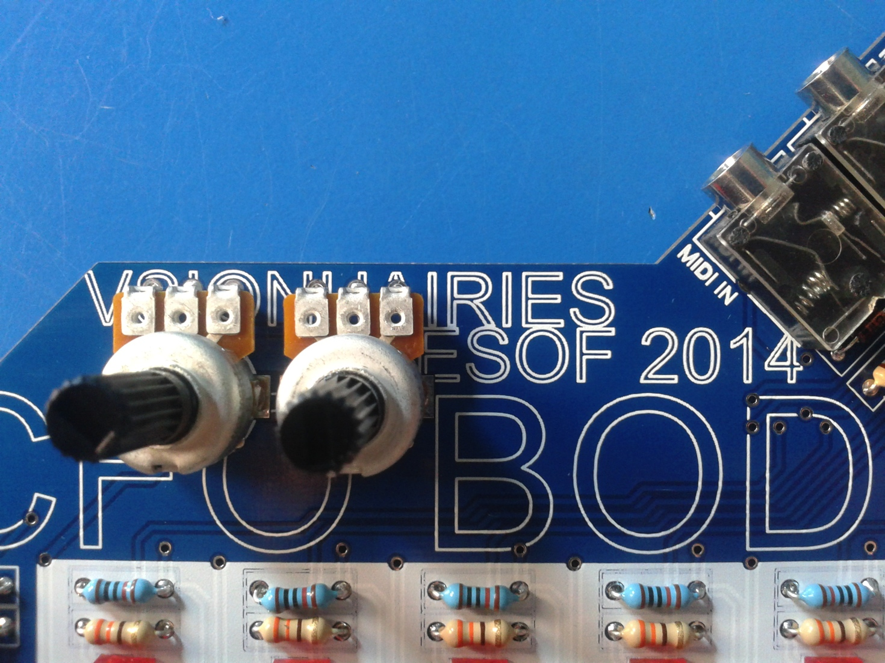

1. attach buttons

***PIC PENDING***

1. get dressed. its ACID TIME!

